 CHEMICAL ENGINEERING TRANSACTIONS  VOL. xxx, 2026 | A publication of  
The Italian Association
of Chemical Engineering
Online at www.cetjournal.it

Guest Editors: Leonardo Tognotti, Rubens Maciel Filho, Viatcheslav Kafarov
Copyright © 2026, AIDIC Servizi S.r.l.
ISBN 979-12-81206-xx-x; ISSN 2283-9216

Feeding Refineries: The extent and limitations of meeting European ethylene demand with agricultural residues
Philippa M. Roots*, Nathalie Márquez Luzardo, Martijn M.P. Zieverink
MNEXT Center of Expertise, Avans Hogeschool, Hogeschoollaan 1 Breda, the Netherlands
pm.roots@avans.nl

Biogenic carbon, such as that from agricultural lignocellulosic residues, is a partial solution to replacing fossil carbon in plastics and chemical products in the materials transition. Mobilizing residual biomass on the scale required for a full transition will require a re-organization of supply chains, as biomass is dispersed across the European continent and not necessarily close to existing processing centers. This study modeled a spatial scenario of a biomass to ethylene system using pyrolysis conversion ratios and a 200 km supply radius to evaluate the magnitude of ethylene producible and resulting supply chain requirements. Crucially, feedstock biomass was limited to sustainable withdrawal levels to avoid incorporating unsustainable soil carbon loss. The results show that with 40 pyrolysis facilities located strategically across Europe, residual agricultural biomass could produce around 4,800 kt of ethylene at 20 industrial crackers, roughly 20 % of existing ethylene demand. Several industrial sites are unsuitably located to receive biomass and are left out of the supply chain, illustrating a shift in future relevance. Managing the circular and land use aspects of production may be critical to maintaining a positive environmental impact.

1. Introduction
In the movement away from fossil carbon and the tightening of resource security, biomass is positioned as a solution for industry and society alike. Biomass has the benefits of being annually renewed, globally occurring, and carbon neutral, allowing local control over supply and captured value. At the scale of the global materials transition, however, these qualities can no longer be assumed. The chemicals and plastics sector is projected to grow to 60 Mt carbon in Europe alone, with 20 – 25 % originating from bio-feedstocks (Plastics Europe 2022). In the simplest terms, this translates to 30 Mt of biomass.
The amount of biomass in use for chemicals today is relatively low. While technology for biomass-to-chemical conversion has been in development for decades and is maturing rapidly, less than 1 % of European chemicals and plastics are currently bio-based (Skoczinski et al. 2024). Nearly all planned or achieved capacity uses starches and sugars from primary crops (a smaller portion uses primary or recovered oils) and can take advantage of existing industry infrastructure. Supply-side focus has thus far been on quantifying the amount of biomass that is available and calculating the increase in production necessary to meet targets without threatening food security, ecosystem health, or competing industries (Carus et al. 2025, Harrandt et al. 2025). Perhaps because of this scope and scale, the entire biomass-to-materials system has received far less scrutiny than it deserves.
Utilization of secondary biomass for chemical production presents a series of connected challenges. To begin, fledgling technologies need a stable supply of relatively clean and homogenous feedstock available in volumes to reach economies of scale and satisfy investors. Outside of niche projects, this will mean either forestry or agricultural residues, which are distributed non-uniformly across Europe. Secondly, large processing capital is immobile in traditionally strategic locations (Rotterdam, Antwerp, etc) and cannot be moved or replaced without losing large sunken costs. Thirdly, reaching sufficient volumes of feedstock to achieve scale will require large supply areas, limited in size by the ability and cost of transporting marginal biomass. As raw biomass is moved in contiguous trips, the cost and travel emissions of inefficient transport can overtake potential savings, limiting supply radius. However, the best supply areas may not be adjacent to existing industrial sites, requiring either long transport line or limiting the volume of product. Transitioning to bio-based chemicals and/or plastics is then not simply a matter of technology, but of locating, collecting, aggregating, and preparing a vast amount of biomass through a complex value chain spread out over new and existing infrastructure.
Thus far few studies have included the spatial element of biomass allocation, either as a limitation or driver of system investment (Comber 2015; Haase 2016). To fill this gap, this study modeled a scenario of residual agricultural biomass to ethylene production in continental Europe and the UK operating with near-future technology and infrastructure parameters.

2. Methods
The project used a spatial modeling approach to evaluate the distribution of agricultural lignocellulosic residues to existing and proposed processing facilities, and the resulting effects on infrastructure and ethylene production. All modeling took place in ArcGis Pro 3.3.0, using the ‘minimize p-impedance’ function of the Location-Allocation toolbox. This function is designed to select a specific number of facilities that minimizes the total distance between demand points and their closest assigned facility. The study included parameters that reflect the state of technology and transport infrastructure in 2021 onwards.
2.1 Data Sources
Agricultural residues can take many forms, but the largest group are the lignocellulosic stems and stalks of common staple crops, also referred to as straw. These agricultural lignocellulosic residues (ALRs) have a market value of 90-120 € t⁻¹ and are otherwise used for animal bedding or disposed of (AHDB 2024). ALRs are a component of most field crops, mirroring the extent of commercial crops which are typically harvested once a year. In this project we used a dataset of ALRs derived from corn, wheat, barley, rye, rapeseed, canola, and oats grown in Europe at a resolution of t km⁻² (Scarlat et al. 2019). Total amounts per unit were reduced by the level needed to remain on the field to maintain soil fertility as per Scarlat et al. (2019). This limit keeps the scenarios from integrating net soil carbon loss into the output.
Ethylene is the largest single chemical market in Europe, typically produced via steam-cracking of naphtha at capacities larger than 100 kt year⁻¹ (Cefic 2021). Due to the scale of the facilities and the benefits of conducting large scale processing at central hubs (Elbersen et al. 2022), the scenarios assummed that final steam cracking takes place at existing ethylene crackers. In 2021 44 ethylene crackers were reported across Europe (Cefic 2021); although some have since closed these locations represent central processing locations for this study.

2.2 Model Parameters
ALRs were aggregated to 500 km² and values under 500 (1 t km⁻²) were removed from analysis as economically unfeasible. The centroid of each aggregate area was then used as the location for all surrounding biomass. Biomass was assumed to be free of contaminants and dried on site. A major non-technical hurdle of bio-feedstock utilization is the challenge of transporting disperse, low-density, and often wet biomass. For this study ALRs were assumed to be collected by the producer and transported by truck from a local storage site to the processing site with a maximum linear procurement distance of 200 km (Cintas 2021) to the pyrolysis facility (Table 1). After conversion, the resulting bio-oil could be transported by pipeline to cracking locations (Figure 1) over a maximum of 400 km (Pootakham and Kumar 2010).
Location Allocation | Input | Demand points | Maximum distance | Mode | Solution quantity | Solution
Pyrolysis | Potential pyrolysis set | Biomass centroids | 200 km | Distance, linear | 20; 40;  80; 100 | Pyrolysis facilities
Crackers | Existing ethylene crackers | Pyrolysis facilities | 400 km | Distance, linear | 44 | Selected crackers
Table 1: Model parameters

Several processing routes are technically feasible to convert ALRs into ethylene. Fast pyrolysis was ideal for this study because it produces bio-oil, which can be co-fed alongside fossil naphtha into existing crackers (N. Márquez Luzardo pers comms, 2025), eliminating the need for entirely new infrastructure and allowing a gradual increase in production share. As a thermochemical process, pyrolysis also avoids the challenge of the low sugar found in lignocellulose, a common hurdle of 2nd generation feedstocks. Through pyrolysis 1 kt of dry biomass is converted to 500 t of bio-oil and 500 t bio-char (Bridgwater 2012). Bio-oil can then be fed into a steam cracker to produce olefins (27 %), CO (17 %), CO₂ (30 %), CH₄ (3.7 %), and C₅₊ (3 %) (Zhu et al. 2025, Gong et al. 2011). In this mass balance 500 t bio-oil produces 46.25 t ethylene, 13.6 t butene, and 76.15 t propylene.

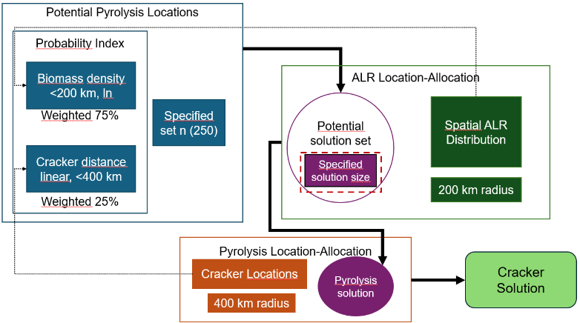
Figure 1: The model consists of three steps: first to create a set of potential pyrolysis locations; second to choose optimal pyrolysis locations based on ALR allocation; and third to allocate pyrolysis output to existing cracker sites.
Pyrolysis locations were selected within the model from a set of 250 potential options semi-randomly located to maximize spread while remaining within the transport limitations. A specified number of pyrolysis location solutions were then chosen by the model (step 2) to minimize total transport distance while allocating biomass (minimize p-impedance). A third step allocated the output of the pyrolysis solution to existing cracker locations to again minimize total transport distance. The model ran several times with variation in the number of allowed location solutions to assess the effect on production volume, transport distance, and facility size.
3. Results and Discussion
Converting European ALRs via fast pyrolysis could produce 3.8 – 4.9 Mt of bio-ethylene annually depending on the spatial arrangement of facilities and capital investment decisions (Table 2). This represents 20 – 25 % of the current ethylene market, in line with predictions of chemical carbon sourcing in 2050 (Plastics Europe 2022). The following sections elaborate on the implications of these scenarios.
scenario | # of pyrolysis facilities | % of total ARLs | total bio-oil capacity  (kt a⁻¹) | Median bio-oil capacity (kt a⁻¹) | # of cracking facilities in solution | total ethylene capacity (kt a⁻¹) | Average km t⁻¹ ethylene | % of 2023 ethylene market (Cefic 2023)
A | 20 | 66 | 41,770 | 1,987 | 17 | 3,864 | 93 | 23
B | 40 | 85 | 51,590 | 1,227 | 25 | 4,772 | 108 | 28
C | 80 | 92 | 53,100 | 521 | 27 | 4,912 | 112 | 29
D | 100 | 92 | 53,740 | 466 | 28 | 4,971 | 102 | 29
Table 2: Output statistics of each scenario

3.1 Pyrolysis capacity
In a spatial distribution system, a low number of facilities will have large individual capacities while capturing a small amount of potential supply, and additional facilities will increase total coverage while lowering average capacity until full coverage is reached. We tested this relationship within four scenarios allocating ALRs to a set of 20 (scenario A), 40 (scenario B), 80 (scenario C), and 100 (scenario D) pyrolysis sites across Europe. Predictably, overall biomass coverage rose with a greater number of facilities, while median capacity size dropped (Table 2). Maximum facility size however remained relatively similar across A, B, and C scenarios (Figure 2), suggesting that a few select areas in Europe (central Germany, western France, and the UK) can support a very large pyrolysis facility.

Figure 2: individual bio-oil capacity from scenarios A, B, C, and D at optimally selected locations across Europe. Total combined ethylene production from allocated cracker sites is shown in the corresponding boxes.
The density of ALRs is not aligned with existing industry infrastructure (Figure 3a). With the addition of pyrolysis sites 66% of ALRs can be reached in scenario A, rising to 85% in scenario B. After 80 facilities, additional facilities split rather than increase overall coverage, implying the remaining 8% is not feasible to obtain. Capacity size is relatively low with 80 facilities however, with less than half reaching 500 kt bio-oil production per annum. Comparatively, all but two facilities in scenario B are over 500 kt. Capital investment is more favourable for larger production volumes, and with a platform chemical such as ethylene facilities much smaller than 500kt may be uneconomical to build (Elbersen et al. 2022).
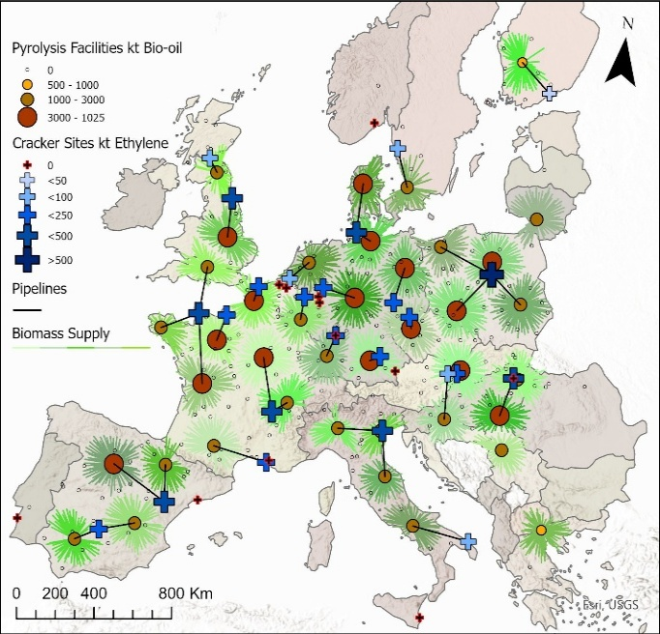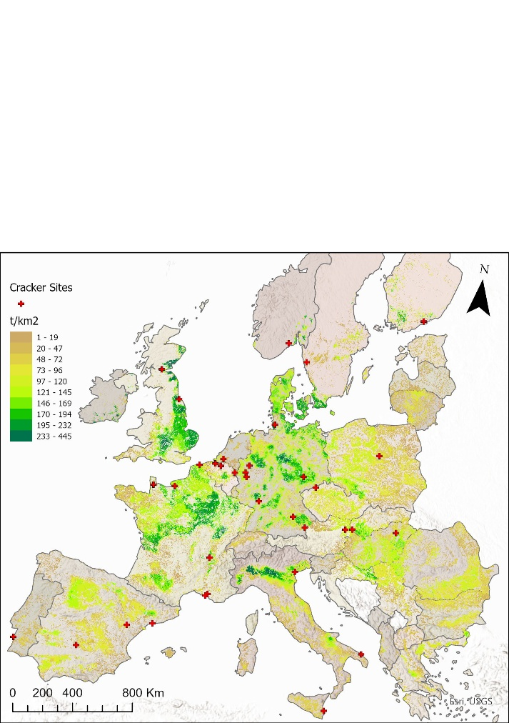
b
a
Figure 3: The location of existing cracker sites in relation to ALR density (a) and the solution of scenario B with ALRs allocated to 40 pyrolysis sites and subsequent bio-oil allocated to 25 cracking locations (b).

3.2 Transport
Transporting straw by truck limits the collection area to the economically feasible distance, leaving hotspots of biomass production out of reach and ‘stranded’ (Elbersen et al. 2022). With 40 pyrolysis facilities approximately 18% of available biomass is out of reach (Figure 3b). The relationship of transport kilometers to product also changes as the number of pyrolysis facilities rise. As collection areas become slightly smaller average supply distance decreases, but this is offset by ineffectively placed facilities which incur long transport lines for relatively low volumes of biomass. In practice transport must follow existing roads, lengthening travel routes over 200 km; these scenarios represent the upper bounds of such a limit. The 200 km biomass supply radius already is near the upper limit of truck transport for unprocessed biomass (Elbersen et al. 2022, Cintas 2021). Even with optimized collection routes, the sheer number of trucks (around 600/day to a median pyrolysis facility given average straw density) would require significant management and road maintenance. Combined transport by train may present a more feasible option, with additional infrastructure investment needed.
Not all industrial sites were chosen as cracking sites for bio-oil, either due to distance from available ALRs, or proximity to a more suitable site. Particularly in southern and northern Europe the density of ALRs are too low to support sizable bio-oil production, leaving industrial sites without feedstocks. In western Europe the legacy of ship transport resulted in clusters of industrial sites within a small area. ALR density in these areas is sufficient to support a small number of crackers, but others are made redundant.
Real-life outcomes would probably be the result of operators reacting to market forces, combined with EU demands for strategic autonomy, overruling purely rational considerations for optimization.

3.3 Environmental Impacts
In the above scenarios roughly 100,000 kt of biomass is removed from fields and transformed into long-lasting materials and other carbon containing by-products. Aside from replacing fossil carbon, this arrangement has other environmental considerations. The main by-product, biochar, has industrial uses in filtration and decontamination of effluents and soils and is gaining traction as an agricultural supplement to improve water retention and soil fertility (Curcio et al. 2025). A closed loop system returning biochar back to ALR source fields may allow for greater proportions of ALRs to be removed without harming soil longevity; this concept was not explored in this study.
In producing ethylene, every tonne of ALR releases 300 kg of CO₂ (Zhu et al. 2025). Biogenic carbon emissions are often considered carbon-neutral, but when considered alongside other lifecycle emissions will contribute to a carbon-positive product. A full lifecycle analysis would compare ALR-based ethylene to fossil ethylene; although not assessed in this study the environmental advantages of ALR based ethylene would likely be influenced by the mode of transport and radius of the feedstock supply area.
The production of ALRs as used in this study relies on industrial monocropping, where one species is grown over a large contiguous area and treated with synthetic biocides and fertilizers (Belete and Yadete 2023). Due to the volumes required to reach commercial scale and the investment involved in collection, large farms producing the same staple crops over multiple years would gain an economic advantage. This is potentially threatening to European climate and nature goals as monocropping is inherently unsustainable (Afshar et al. 2025; Belete and Yadete 2023) and creating decades long demand from industry could lock-in agriculture from transitioning to more ecological practices.

4. Conclusions
This study shows that using available and accessible European agricultural lignocellulosic residues (ALRs) it is theoretically possible to produce enough bio-oil to cover 20% of current EU ethylene production. With at least 40 new pyrolysis sites more than 80 % of ALRs are within a 200 km supply radius. Importantly, not all existing cracking sites are suitably located to be fed with ALR-based bio-oil with the transportation limits used in this study. This illustrates that in a future shift from imported fossil to EU sourced renewable feedstocks not all existing refinery infrastructure can expect to remain relevant. Making full use of pyrolysis by-products could improve environmental outcomes, but the CO₂ emissions in combination with agricultural implications may prevent the system from becoming a full climate solution. While feasible from volumes and maturity of technologies alone, a closer examination of producing Europe’s ethylene via pyrolysis from agricultural residues reveals significant hurdles in application.
Acknowledgments
Part of this work was financed by Regieorgaan SIA as part of the project ‘FeedingRefineries: mapping resources for the bio-transition’ (Goch.KIEM.KGC04.047).
References
Afshar, M. H., Hassani, A., Aminzadeh, M., Borrelli, P., Panagos, P., Robinson, D. A., Shokri, N., 2025, Spatial and temporal assessment of soil degradation risk in Europe, Scientific reports.
AHDB, 2024, Hay and straw prices, AHDB <Ahdb.org.uk. ahdb.org.uk/dairy/hay-and-straw-prices> accessed 16.01.2026.
Belete, T., Yadete, E., 2023, Effect of Mono Cropping on Soil Health and Fertility Management for Sustainable Agriculture Practices: A Review, Journal of Plant Sciences, 11(6), 192–197.
Bridgwater, A.V., 2012, Review of fast pyrolysis of biomass and product upgrading, Biomass and Bioenergy, 38, 68-94.
Carus, M., Porc, O., vom Berg, C., Kempen, M., Schier, F., Tandetzki, J., 2025, Is there enough biomass to defossilise the chemicals and derived materials sector by 2050, Nova Institut GmbH (Ed.), Hürth, Germany.
Cefic, 2021, Cracker Capacity Petrochemicals Europe <petrochemistry.eu/about-petrochemistry/petrochemicals-facts-and-figures/cracker-capacity> accessed 15.09.2025.
Cefic, 2023, Quarterly Production Statistics, Petrochemicals Europe <petrochemistry.eu/about-petrochemistry/petrochemicals-facts-and-figures/quarterly-production-statistics> accessed 21.11.2025
Cintas, O., Berndes, G., Englund, O., Johnsson, F., 2021, Geospatial supply-demand modeling of lignocellulosic biomass for electricity and biofuels in the European Union, Biomass and Bioenergy, 144, 105870.
Comber, A., Dickie, J., Jarvis, C., Phillips, M., Tansey, K., 2015, Locating bioenergy facilities using a modified GIS-based location–allocation-algorithm: Considering the spatial distribution of resource supply, Applied Energy, 154, 309–316.
Curcio, R., Bilotti, R., Lia, C., Compitiello, M., Cangemi, S., Verrillo, M., Mazzei, P., 2025, Short-Term Effects of Wood Biochar on Soil Fertility, Heterotrophic Respiration and Organic Matter Composition, Agriculture, 15(10), 1091.
Elbersen, W., Gursel, I. V., Voogt, J., Meesters, K., Kulisic, B., 2022, To be or not to be a biobased commodity: assessing requirements and candidates for lignocellulosic based commodities.
Gong, F., Yang, Z., Hong, C., Huang, W., Ning, S., Zhang, Z., Li, Q., 2011, Selective conversion of bio-oil to light olefins: controlling catalytic cracking for maximum olefins, Bioresource technology, 102(19), 9247–9254.
Haase, M., Rösch, C., Ketzer, D., 2016, GIS-based assessment of sustainable crop residue potentials in European regions, Biomass and Bioenergy, 86, 156171.
Harrandt, J., Carus, M., vom Berg, C., Hark, N., 2025, EU and global: Biomass ​Demand for Transport Fuels, Aviation and Shipping up to 2050 and Implications for Biomass Supply to the Chemical Sector, Nova Institut GmbH (Ed.), Hürth, Germany.
Plastics Europe, 2022. The Plastics Transition. <plasticseurope.org/wp-content/uploads/2024/09/2310838_RoadmapCopyChange_110924.pdf> accessed 20.04.2025
Pootakham, T. and Kumar, A., 2010, Bio-oil transport by pipeline: A techno-economic assessment, Bioresource technology, 101(18), 7137–7143.
Scarlat, N., Fahl, F., Lugato, E., Monforti-Ferrario, F., Dallemand, J. F., 2019, Integrated and spatially explicit assessment of sustainable crop residues potential in Europe. Biomass and Bioenergy, 122, 257–269.
Skoczinski, P., Carus, M., Tweddle, G., Ruiz, P., Hark, N., Zhang, A., Raschka, A., 2024, Bio-based building blocks and polymers global capacities, production and trends 2023–2028, Industrial Biotechnology, 20(2), 52–59.
Wright, M. M., Satrio, J. A., Brown, R. C., Daugaard, D. E., Hsu, D. D., 2010, Techno-economic analysis of biomass pyrolysis to transportation fuels, National Renewable Energy Laboratory, Golden, USA.
Zhu, J., Cai, N., Zhao, C., Yang, H., 2025, Research Progress on Thermochemical Conversion Technologies for Hydrogen Production from Waste Plastics, Applications in Energy and Combustion Science, 100451.

